Manual Guide for UK, DE and US shipment

- Get the file in sir Chris Yunun email shipment for SO and PO, then download.
Sample of shipment email:
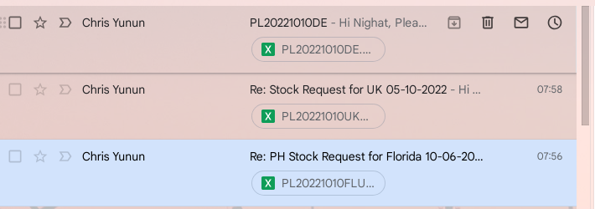
For example, FL shipment:
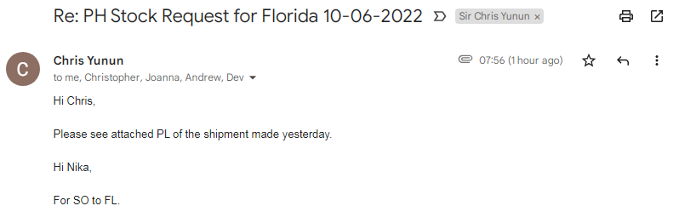
File to download:
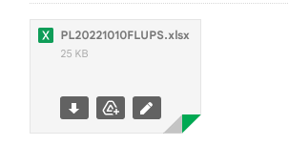

Open the file 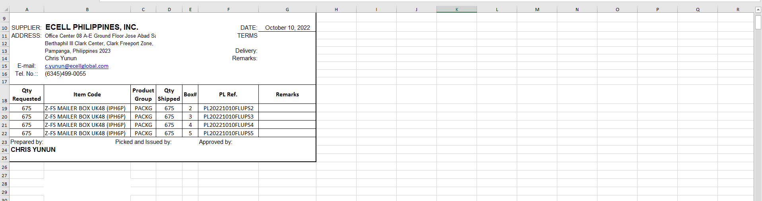
And get the “Item Code and Quantity Shipped”, use PIVOT
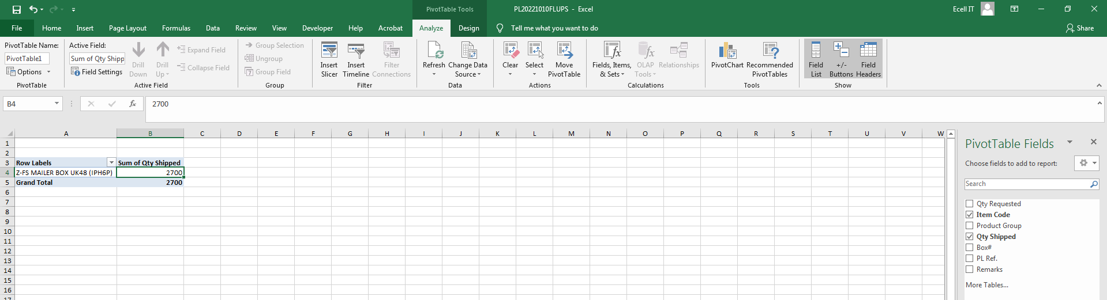
After the PIVOT process get the result and paste it to another file, this is the format: (Column A: Code and Column B: Qty) then save it as CSV, Sample File:
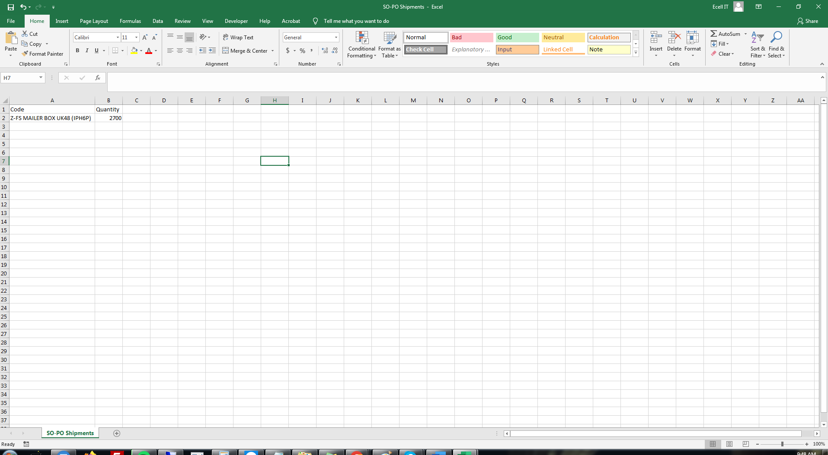
- Free Stocks Check, to check if the item code is added in Zero, if the item code is not added in Zero ask sir Chris Yunun “if the item code given is correct or is not yet added in Zero.
http://34.196.137.61/barcode/zero_free_stocks.php
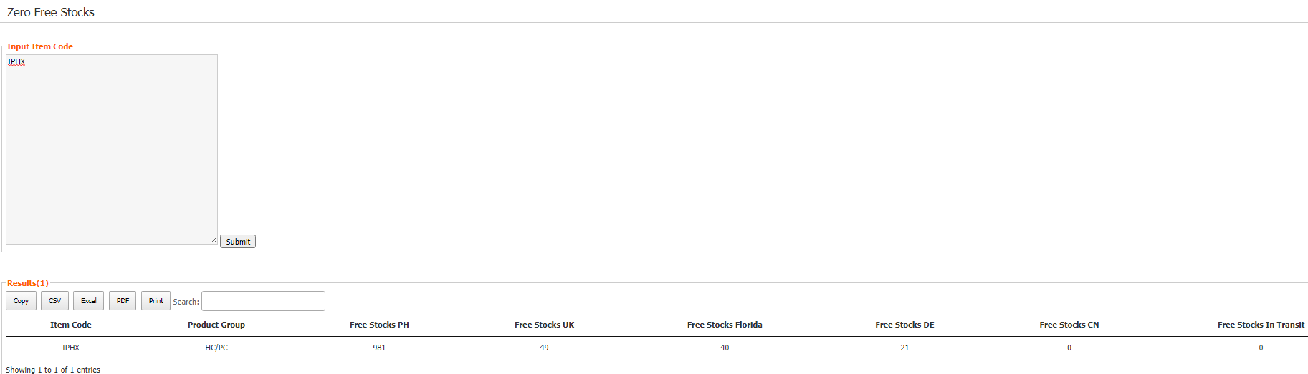

- Convert Price, Download the CSV file you made in this page:
http://34.196.137.61/barcode/ukus_convert_price.php
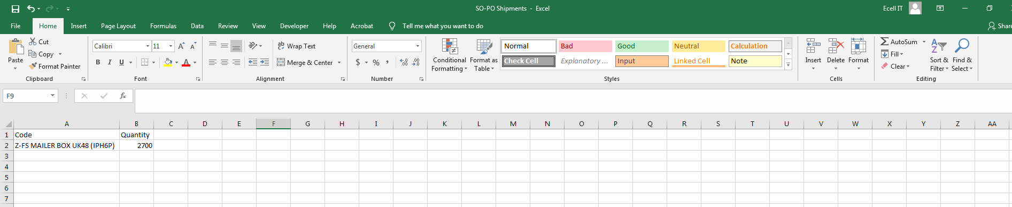
Select shipment date according to the PL date : PL20241219FLUPS and in the Choose : select US shipment, or if the shipment is UK select UK shipment and if is DE select DE shipment.
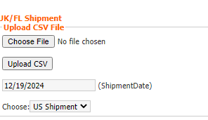
Then click the upload CSV, after uploading the CSV >download the SO file and PO file.
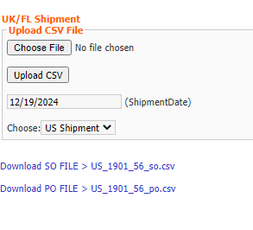

- Create PO, Upload PO file - >Check Follow File Pricing -> Select Warehouse->
Select Supplier: ECELLMFG

UK Shipment -> Warehouse: UK
DE Shipment -> Warehouse: DE
US Shipment -> Warehouse: Florida
http://34.196.137.61/barcode/zero_generate_purchase_orders_mfg.php
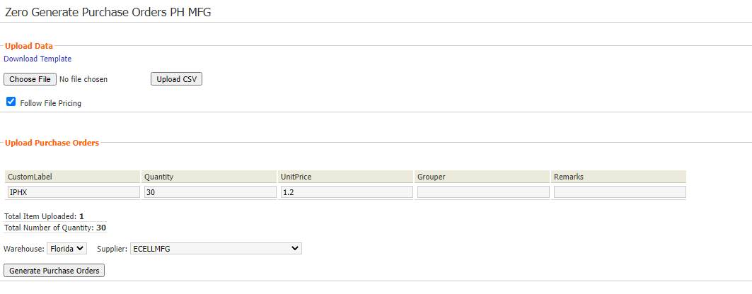
- Create SO, Upload SO file -> Select Warehouse: PH

http://34.196.137.61/barcode/zero_generate_sales_orders.php
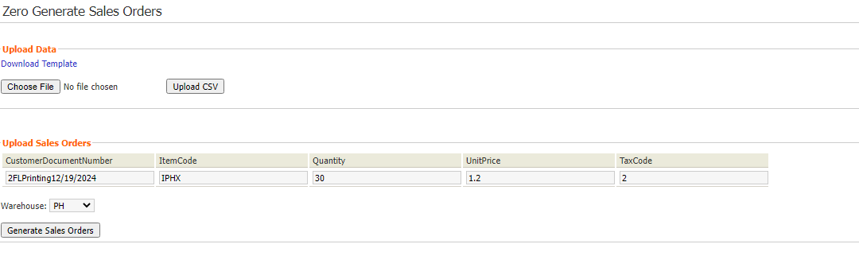

- Dispatch SO Number
Click the Generated SO number -> Click Dispatch items (PH warehouse) -> for reference input the PL number -> Click OK
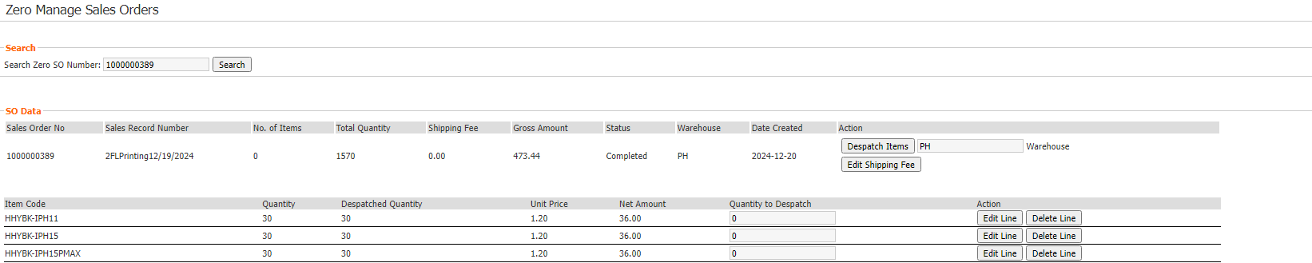

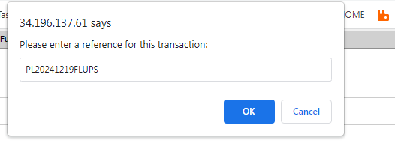

- Email Template
For UK
Hi,

Please see generated SO/PO for UK shipment.
UK
Date Month/Day/Year (PL number)
PO –
SO –
@UK
Kindly receive the PO number:
PO –
Please let us know if you have any issues/concerns.
--------------------------------------------------------------------------------------------------------------------------

For DE
Hi,

Please see generated SO/PO for DE shipment.
DE
Date Month/Day/Year (PL number)
PO –
SO –
@DE
Kindly receive the PO number:
PO –
Please let us know if you have any issues/concerns.
--------------------------------------------------------------------------------------------------------------------------

For US/FL
Hi,

Please see generated SO/PO for US shipment.
US
Date Month/Day/Year (PL number)
PO –
SO –
@US
Kindly receive the PO number:
PO –
Please let us know if you have any issues/concerns.
- Sending Email>Reply to all>Copy and Paste SO and PO> Attached download SO and PO file>then send.
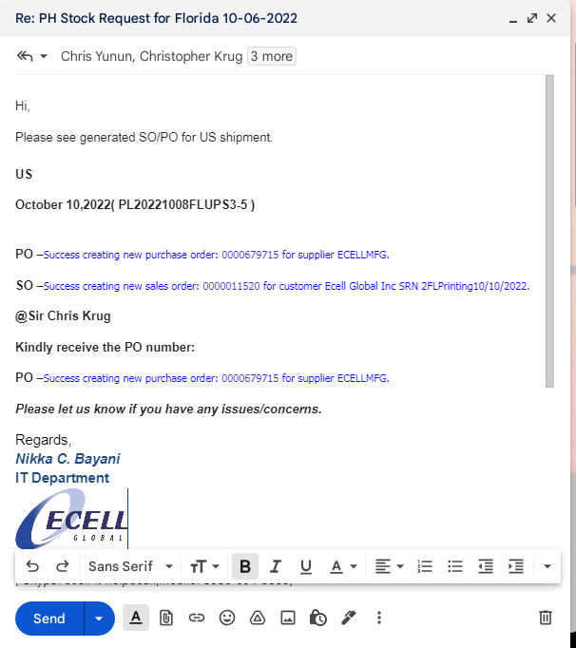
- The end :D

